**Objective and Subjective Questions Analysis**

**Objective Questions**

**1.Are there any tables with duplicate or missing null values? If so, how would you handle them?**

Ans:

No duplicate of missing null values has been found across all the tables in database ig_clone

If so, following steps will be taken to handle missing null values or duplicate values

Delete the missing or null values.

Use coalesces () to fill those NULL values with 0.

**2.What is the distribution of user activity levels (e.g., number of posts, likes, comments) across the user base?**

Ans:

Need to aggregate the number of posts, likes, and comments per user from the respective tables (photos, likes, and comments).

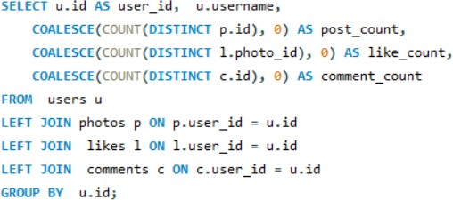Query

|  |  |  |  |  |
| --- | --- | --- | --- | --- |
| **user_id** | **username** | **post_count** | **like_count** | **comment_count** |
| 1 | Kenton_Kirlin | 5 | 0 | 0 |
| 2 | Andre_Purdy85 | 4 | 94 | 66 |
| 3 | Harley_Lind18 | 4 | 79 | 67 |
| 4 | Arely_Bogan63 | 3 | 93 | 64 |
| 5 | Aniya_Hackett | 0 | 257 | 257 |

**Query** **Result**

**Suggestions**:

Identify users with many posts but low engagement (low engagement_ratio) and consider offering content suggestions or engagement strategies, such as prompts for interaction or community features showing them examples of users with high engagements

Users with high engagement (likes and comments) relative to their post count can be encouraged to create more content through rewards or special recognition.

**3.Calculate the average number of tags per post (photo_tags and photos tables).**

Ans:

**Query**:

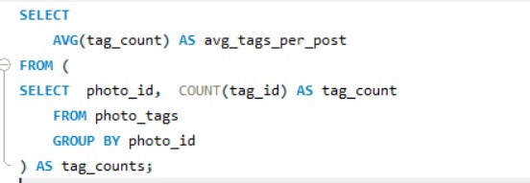

**Query Result:**

Avg_tags_per_cost: 2.6368

**Explanation:**

**Subquery:** To find the average tags per post, count of tag_id is determined from photo_tags

Main Query: Calculate the average of these tag counts to get the average number of tags per post.

**Suggestions**:

1. Since the aggregate function is used grouping by user would have given deep insights into the users who are utilizing tags more effectively to increase post reachability and engagement.

**4.Identify the top users with the highest engagement rates (likes, comments) on their posts and rank them.**

Ans:

**Query:**

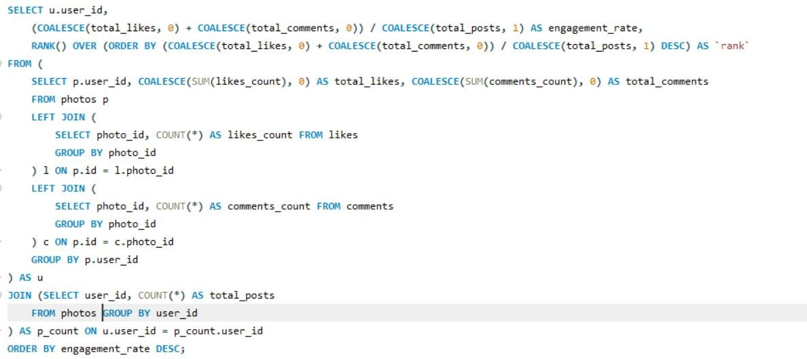

**Query Result:**

|  |  |  |
| --- | --- | --- |
| **user_id** | **engagement_rate** | **Rank** |
| 55 | 75 | 1 |
| 73 | 73 | 2 |
| 48 | 71 | 3 |
| 22 | 70 | 4 |
| 94 | 68 | 5 |
| 87 | 68 | 5 |
| 69 | 68 | 5 |
| 18 | 67 | 8 |
| 43 | 66.8 | 9 |

**Query Explanation:**

* Total likes and comments: The first query aggregated the likes and comments each user has received on their posts.
* Total posts per user: The second query calculates the total number of posts each user has made
* Engagement rate: The engagement rate is calculated by the last query as the sum of likes and comments divided by the number of posts, and users are ranked based on this rate.

**Suggestions**:

* The query offers a good balance between likes and comments, making it valuable to measure overall user impact, not just based on likes but on user interactions as well (through comments).
* It provides a summary of user activity by combining the total likes and comments received by each user. This can be used to gauge user engagement on the platform.

**5.Which users have the highest number of followers and followings?**

Ans:

User with most followers

**Query**:

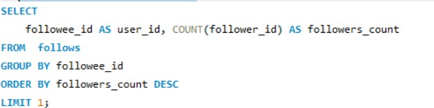

The count function of the query helped to determine how many users are following each followee_id

Query Result:

|  |  |
| --- | --- |
| **user_id** | **followers_count** |
| 1 | 77 |

Users with the most followings:

**Query**

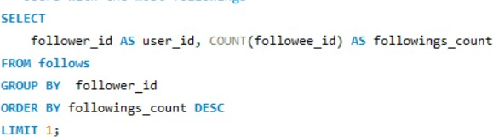

Here the count function has helped to determine how many user each follower_id is following.

**Result**:

|  |  |
| --- | --- |
| **user_id** | **followings_count** |
| 2 | 99 |

**Suggestions:**

* User with most followers is highlighting the most popular account among others, it is useful in understanding the prominent or the influential among others
* User with most following is highlighting the level of engagement on the platform, time spent by the user on platform.

**6.Calculate the average engagement rate (likes, comments) per post for each user.**

Ans:

**Query:**

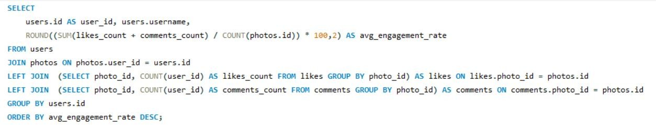

**Query Result:**

|  |  |  |
| --- | --- | --- |
| **user_id** | **Username** | **avg_engagement_rate** |
| 55 | Meggie_Doyle | 7500 |
| 73 | Jaylan.Lakin | 7300 |
| 48 | Granville_Kutch | 7100 |
| 22 | Kenneth64 | 7000 |
| 94 | Damon35 | 6800 |
| 87 | Rick29 | 6800 |
| 69 | Karley_Bosco | 6800 |
| 18 | Odessa2 | 6700 |

**Explanation:**

To calculate average engagement rate per post following step by step process has been followed

likes_count: The number of likes per post.

comments_count: Number of comments per post

avg_engagement_rate: Total engagements per post for each user, expressed as a percentage

**Suggestions:**   
  
Identifies users whose content generates high engagement (likes and comments), highlighting potential influencers or active users.

The query shows the average engagement per post, which helps evaluate how well users' posts are performing in terms of interaction.

**7.Get the list of users who have never liked any post (users and likes tables)**

Ans:

**Query:**

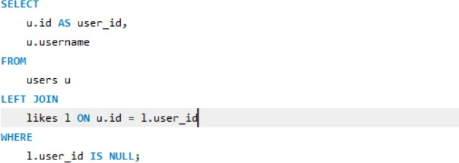

**Query Result:**

|  |  |
| --- | --- |
| **user_id** | **Username** |
| 1 | Kenton_Kirlin |
| 7 | Kasandra_Homenick |
| 23 | Eveline95 |
| 25 | Tierra.Trantow |
| 29 | Jaime53 |
| 34 | Pearl7 |
| 45 | David.Osinski47 |
| 49 | Morgan.Kassulke |

**Explanation**:

* LEFT JOIN returns all the users from the users table along with any corresponding data from the likes table
* Performing l.user_id is NULL filtered the users who do not have any data in the likes tables that answers the question they haven’t liked any post.

Suggestions:

* This query helped to check what users have less engagement on the platform and the users to be worked upon with engagement strategies, prompts or special notifications, notification

8.How can you leverage user-generated content (posts, hashtags, photo tags) to create more personalized and engaging ad campaigns?

Ans:

Leveraging user-generated content such as posts, hashtags, and photo tags can powerfully enhance the personalization and engagement levels of ad campaigns. Here’s how the data from an Instagram-like platform (including users, posts, hashtags, and photo tags) can be utilized effectively:

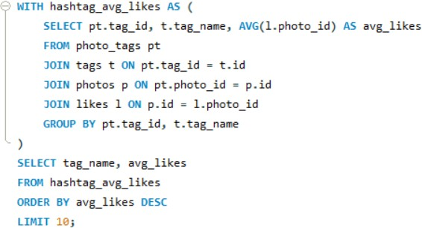

Code :-

**Personalized Ads Based on User Interests:**

**Content:**

* Analyze posts that users have liked or commented on.
* Identify patterns in the types of content users frequently engage with (e.g., themes like fitness, travel, or tech).

**Action**:

* Create targeted ads for products or services that match the content users show interest in.
* Deliver personalized ads based on these insights, increasing relevance and engagement with the audience.

Trending Hashtags for Ad Campaigns:

**Content**:

* Monitor and analyze hashtags that users frequently use or engage with to identify trending themes and topics of interest.

**Action**:

* Incorporate these trending hashtags into ad campaigns to create a sense of timeliness and relevance, aligning ads with current user interests and conversations.

Ad Campaigns Based on Follower Behaviour:

**Content**:

* Track and analyze users’ interactions with followers, such as likes, comments, and follows, to gain insights into shared interests and community dynamics.

**Action**:

* Create ads that reflect the common interests within follower groups, enhancing relevance and fostering a sense of community by aligning with the mutual interests of users and their connections.

**9. Are there any correlations between user activity levels and specific content types (e.g., photos, videos, reels)? How can this information guide content creation and curation strategies?**

Ans

Analyzing correlations between user activity levels and specific content types, such as photos, videos, and reels, can reveal valuable insights into audience preferences. For example, if users are more engaged with reels than with photos, it suggests a preference for dynamic, short-form content. Here’s how this information can shape content creation and curation strategies:

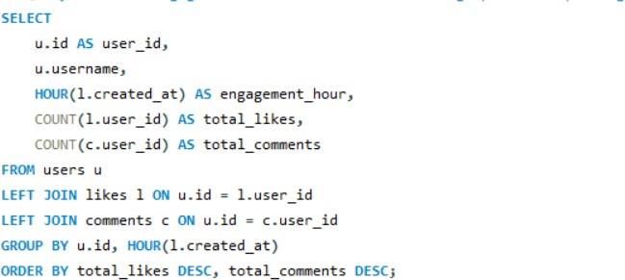

**Photos**:

* Users are often quick to engage with photos, especially when the content is visually captivating or aligns with their personal interests, such as stunning landscapes or lifestyle imagery
* Use high-quality, relevant images to captivate viewers' attention and drive engagement.

**Videos:**

* Videos, particularly short-form videos (e.g., reels), tend to have higher engagement levels. These formats can captivate users longer and drive interactions such as likes, shares, and comments.

**Reels:**

* Platforms have noted a substantial increase in engagement with short-form content like reels, especially among younger audiences. This format fosters frequent interactions and repeat visits, making it highly effective for building ongoing engagement
* Incorporating reels and other short-form content into your strategy can harness their viral potential, maximizing reach.

**10.Calculate the total number of likes, comments, and photo tags for each user.**

Ans:

**Query:**

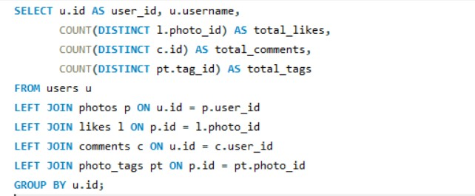

**Query Result:**

|  |  |  |  |  |
| --- | --- | --- | --- | --- |
| **user_id** | **username** | **total_likes** | **total_comments** | **total_tags** |
| 1 | Kenton_Kirlin | 5 | 0 | 15 |
| 2 | Andre_Purdy85 | 4 | 66 | 7 |
| 3 | Harley_Lind18 | 4 | 67 | 7 |
| 4 | Arely_Bogan63 | 3 | 64 | 2 |
| 5 | Aniya_Hackett | 0 | 257 | 0 |

**Explanation:**

* The query returned the data for each user and counts the distinct number of likes, comments, and tags on photos uploaded by the user.
* Used LEFT JOIN to connect the users table with the photos, likes, comments, and photo_tags tables, ensuring that even if there are no likes, comments, or tags, the user is still included in the results

Suggestions:

* The query provides and overview of how active each user is based on the number of photos they have that were liked (total_likes), how many comments they made (total_comments), and the total tags associated with their photos (total_tags).
* Users receiving high numbers of likes or comments exhibits more engagement with their content reflecting a strong connection with their audience.
* Users with multiples tags on their photos may have more visibility or engagement through different categories or topics.

**11.Rank users based on their total engagement (likes, comments, shares) over a month.**

Ans:

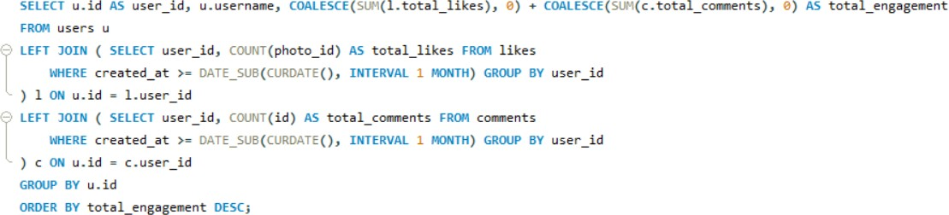**Query**:

**Query Result:**

|  |  |  |
| --- | --- | --- |
| **user_id** | **Username** | **total_engagement** |
| 71 | Nia_Haag | 514 |
| 5 | Aniya_Hackett | 514 |
| 41 | Mckenna17 | 514 |
| 21 | Rocio33 | 514 |
| 66 | Mike.Auer39 | 514 |
| 54 | Duane60 | 514 |
| 24 | Maxwell.Halvorson | 514 |
| 14 | Jaclyn81 | 514 |
| 57 | Julien_Schmidt | 514 |

**Explanation:**

The query calculates the total engagement for every user, that is the sum of likes, comments, and shares over the past month. “COALESCE” is used to handle cases where there are no likes, comments, or shares, returned a default value of 0.

The LEFT JOIN is used to join the users table with subqueries that count likes, comments, and shares, ensuring that all users are included, even those without activity in the past month.

**Suggestions:**

* Tailor content to users' preferences to keep them actively engaged. Personalized recommendations, notifications, or content can significantly boost interactions such as likes and comments.
* Ensure that interacting with content (liking, commenting, or sharing) is easy and intuitive. A frictionless user interface can increase engagement and user satisfaction

**12.Retrieve the hashtags that have been used in posts with the highest average number of likes. Use a CTE to calculate the average likes for each hashtag first.**

Ans:

**Query**:



**Query Result:**

|  |  |
| --- | --- |
| **tag_name** | **avg_likes** |
| Photography | 157.5725 |
| Landscape | 154.373 |
| Sunset | 152.4877 |
| Sunrise | 146.8415 |
| Beach | 142.3867 |
| Style | 138.372 |
| Dreamy | 136.1594 |
| Stunning | 133.7281 |
| Fashion | 129.8219 |
| Delicious | 127.9542 |

**Explanation**:

* Determined the average number of likes (AVG(l.likes_count)) for each hashtag (t.tag_name) by joining the photo_tags, photos, tags, and likes tables.Then results are grouped by the tag_name.
* The main query retrieves the hashtags and their average likes from the CTE, ordered by avg_likes in descending order to get the most popular hashtags.
* LIMIT 10 ensures that only the top 10 hashtags with the highest average likes are returned.

**Suggestions:**

* Based on the average likes query has helped to identify what kind of content has the highest engagement by users
* Further analysing the rationale behind the higher engagement of the hashtags, tracing their category, user preferences, tastes of common people

**13.Retrieve the users who have started following someone after being followed by that person**

Ans:

**Query**:

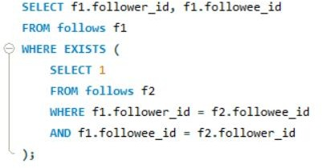

**Query** **Result**:

|  |  |
| --- | --- |
| **follower_id** | **followee_id** |
| 3 | 2 |
| 4 | 2 |
| 5 | 2 |
| 6 | 2 |
| 8 | 2 |
| 9 | 2 |
| 10 | 2 |
| 11 | 2 |

**Explanation**:

* The result table contains two columns (follower_id, followee_id), representing who follows whom.
* EXISTS clause: It has checked if there is a reverse relationship for every follower_id in the follows table (i.e., if the followee_id has also followed back the follower_id).

**Suggestions:**

* Identifying mutual followers, helps to know how many users reciprocate follow actions.
* Target users who follow each other for potential friend suggestions or mutual- interest recommendations.

**Subjective Questions:**

**1.Based on user engagement and activity levels, which users would you consider the most loyal or valuable? How would you reward or incentivize these users?**

Ans:

Users having maximum likes, comments and follows are often the most loyal and valuable user. Their regular interaction with content signals a strong interest and a deeper connection with the platform or brand.

Query:

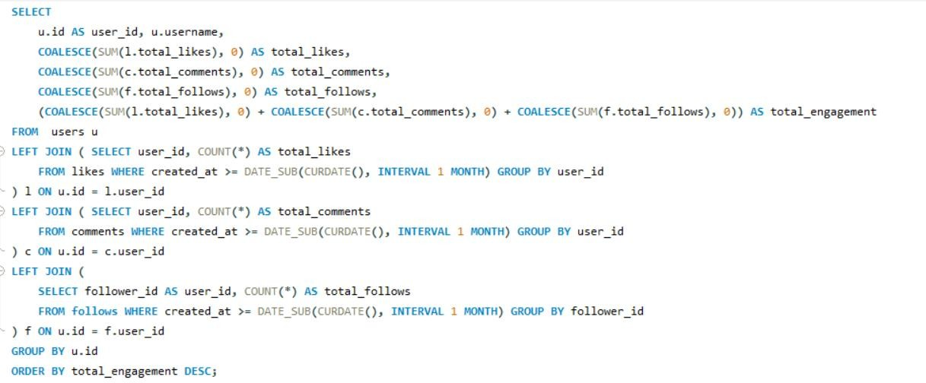

**Query Result:**

|  |  |  |  |  |  |
| --- | --- | --- | --- | --- | --- |
| **user_id** | **username** | **total_likes** | **total_comments** | **total_follows** | **total_engagement** |
| 71 | Nia_Haag | 257 | 257 | 99 | 613 |
| 5 | Aniya_Hackett | 257 | 257 | 99 | 613 |
| 41 | Mckenna17 | 257 | 257 | 99 | 613 |
| 21 | Rocio33 | 257 | 257 | 99 | 613 |
| 66 | Mike.Auer39 | 257 | 257 | 99 | 613 |
| 54 | Duane60 | 257 | 257 | 99 | 613 |
| 24 | Maxwell.Halvorson | 257 | 257 | 99 | 613 |
| 14 | Jaclyn81 | 257 | 257 | 99 | 613 |
| 57 | Julien_Schmidt | 257 | 257 | 99 | 613 |

**Explanation:**

* **User Engagement:** Query has determined the total number of likes, comments, and follows each user has received in the past month.
* **COALESCE & Aggregation:** The COALESCE function has ensured that users with no activity in a given category get a 0 count instead of NULL. The total engagement is the sum of these values.
* **Sorting by Engagement:** The users are sorted by total_engagement in descending order, with the most active users at the top.

**Approach to Reward or Incentivize Loyal Users:**

* **Special Status in Community Interactions**: Grant them access to “verified” or “premium” status during interactions, which could include special icons or color-coded usernames, recognizing their commitment to the platform.
* **VIP Experiences**: Invite top users to exclusive virtual events, Q&A sessions with creators, or behind-the-scenes content that adds value to their experience on the platform.
* **Early Access to Sales or Limited-Edition Products**: Give loyal users priority access to limited-edition items or flash sales as a way to reward their continued support.

**Criteria for Loyalty:**

* High Total Engagement: Active involvement in commenting, liking, and participating in discussions.
* Activity Over Time: Consider consistent activity over time, not just one-off high engagement

**2.For inactive users, what strategies would you recommend to re-engage them and encourage them to start posting or engaging again?**

Ans:

**Query:**

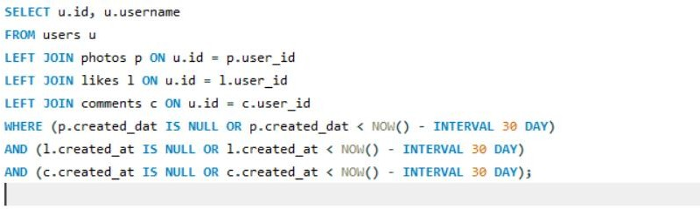

**Query Result:**

|  |  |
| --- | --- |
| **id** | **username** |
| 7 | Kasandra_Homenick |
| 25 | Tierra.Trantow |
| 34 | Pearl7 |
| 45 | David.Osinski47 |
| 49 | Morgan.Kassulke |
| 53 | Linnea59 |
| 68 | Franco_Keebler64 |
| 74 | Hulda.Macejkovic |
| 80 | Darby_Herzog |

**Explanation**:

* Inactive Users: Query has returned the list of users who haven't posted, liked, or commented in the last 30 days.
* Left Join: Used Left join to make sure all user even with no activity are included
* Filter: The conditions filters users who have no engagement within the last 30 days.

**Strategies to Re-engage Inactive Users:**

* **Offer Personalized Re-Onboarding**: Design a welcome-back experience that highlights new features, improvements, or benefits since their last activity to spark renewed interest and show progress.
* **Introduce Gamified Challenges or Contests**: Run engaging challenges with rewards for returning users, fostering a sense of excitement and community competition.
* **Bring Attention to User Milestones**: Send reminders of their past achievements or engagement milestones on the platform, encouraging them to continue building on their previous activity.
* **Send Updates on New Community Features**: Highlight recent community-driven features like groups, forums, or live events, inviting users to rejoin a more vibrant and connected community.

3.Which hashtags or content topics have the highest engagement rates? How can this information guide content strategy and ad campaigns?

Ans:

**Query**:

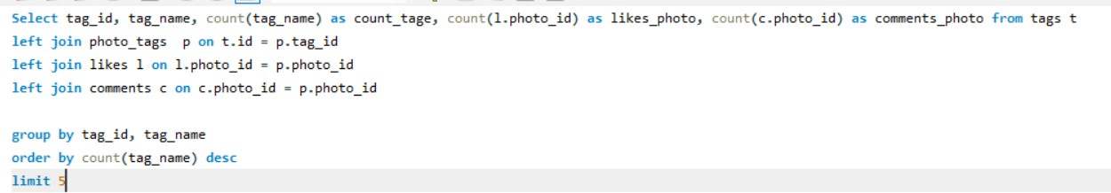

**Query Result:**

|  |  |  |  |  |
| --- | --- | --- | --- | --- |
| **tag_id** | **tag_name** | **count_tage** | **likes_photo** | **comments_photo** |
| 21 | Smile | 59199 | 59199 | 59199 |
| 20 | Beach | 41935 | 41935 | 41935 |
| 17 | Party | 38939 | 38939 | 38939 |
| 13 | Fun | 37145 | 37145 | 37145 |
| 5 | Food | 24619 | 24619 | 24619 |
| 11 | Lol | 23643 | 23643 | 23643 |
| 18 | Concert | 23065 | 23065 | 23065 |

**Explanation**:

* Joins: Joined the tags table with photo_tags, photos, likes, and comments to determine engagement metrics (likes + comments).
* Aggregation: After performing the join used aggregate function to calculate total number of likes and comments for each hashtag
* Order and Limit: Output has been ordered by total engagement in descending order and the top 10 hashtags

**Analyzing hashtags:**

The query results show that "smile," "beach," "party," "fun," and "food" have the highest engagement, these popular themes can guide the creation of more targeted, relatable content that resonates with users’ interests and enhances interaction on the platform.

**Content Strategy:**

* Center content creation around these high-engagement themes, For example, highlight a joyful, lively atmosphere with visuals that capture the essence of parties, food, and beach scenes. This approach will resonate with audiences and drive greater interaction.
* Boost engagement by sharing user content that naturally highlights these popular themes.

**Ad Campaigns:**

* Tailor ad creatives to incorporate these popular hashtags, making the campaigns resonate with user preferences. Ads featuring "beach" and "party" visuals can boost the reach among audiences interested in lifestyle and leisure.
* Use these hashtags in paid promotions to target specific user groups who engage with similar content, increasing click-through rates and conversions.

**4.Are there any patterns or trends in user engagement based on demographics (age, location, gender) or posting times? How can these insights inform targeted marketing campaigns?**

Ans:

**Query:**



**Query Result:**

|  |  |  |  |  |
| --- | --- | --- | --- | --- |
| **user_id** | **username** | **engagement_hour** | **total_likes** | **total_comments** |
| 36 | Ollie_Ledner37 | 17 | 66049 | 66049 |
| 71 | Nia_Haag | 17 | 66049 | 66049 |
| 57 | Julien_Schmidt | 17 | 66049 | 66049 |
| 5 | Aniya_Hackett | 17 | 66049 | 66049 |
| 24 | Maxwell.Halvorson | 17 | 66049 | 66049 |
| 41 | Mckenna17 | 17 | 66049 | 66049 |
| 21 | Rocio33 | 17 | 66049 | 66049 |
| 14 | Jaclyn81 | 17 | 66049 | 66049 |

**Explanation:**

* LEFT JOIN: Joined the tags table with users, likes, and comments to calculate engagement metrics (likes + comments).
* Aggregation: Query returned the number of total_likes, total_comments and engagement hours of the users.
* **Order** : Results are ordered by total like and total comments in descending order.
* Examining user engagement by demographics and posting times can reveal valuable trends to decide marketing strategies. Potential patterns might include:

**Demographic Insights:**

* Certain age groups, locations, or genders may interact more frequently with specific types of content.
* Example: Platforms like Instagram see high engagement from Gen Z with viral dance trends and lifestyle content, while LinkedIn attracts older professionals engaging with career tips and industry news.

**Posting Times:**

* Engagement might vary based on the time of day or week.
* Example: Posts made during weekends could attract higher engagement, while off-peak times like weekdays might work for specific user types

**Marketing Campaign Implications:**

* Targeting: Marketing campaigns can be adjusted to post at times when the target audience is most active. Demographics can be segmented to create more personalized ads (e.g., fun content for younger users, inform ative posts for professionals).
* Content Personalization: By evaluating which demographic engages with what type of content, brands will create more relevant and effective ads that match with their specific audience.

**5.Based on follower counts and engagement rates, which users would be ideal candidates for influencer marketing campaigns? How would you approach and collaborate with these influencers?**

Ans:

**Query**:

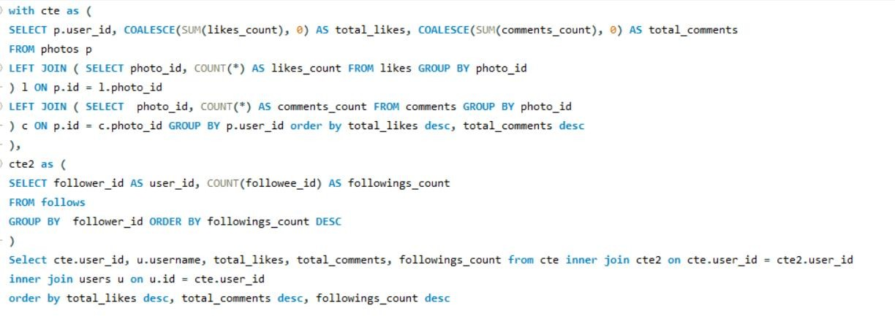

**Query result:**

|  |  |  |  |  |
| --- | --- | --- | --- | --- |
| user_id | Username | total_likes | total_comments | followings_count |
| 52 | Zack_Kemmer93 | 182 | 151 | 99 |
| 13 | Alexandro35 | 181 | 148 | 99 |
| 43 | Janet.Armstrong | 180 | 154 | 99 |
| 65 | Adelle96 | 179 | 142 | 99 |
| 78 | Colten.Harris76 | 177 | 143 | 99 |
| 33 | Yvette.Gottlieb91 | 175 | 141 | 99 |

**Explanation**:

* CTE (Common Table Expressions):
* The first CTE determined total likes and comments for each user's photos.
* The second CTE determined how many users each influencer is following (followings_count).
* The main query combines CTE results with user data to rank influencers by their total likes, comments, and follower count, highlighting the most engaging and influential users on the platform.
* The ideal candidates for influencer marketing campaigns are users who have high levels of engagement, such as likes and comments, along with a significant follower count. These metrics reflect active users who consistently create and interact with content, positioning them as effective influencers within the platform.
* For instance, Zack_Kemmer93 boasts 182 likes, 151 comments, and 99 followers, positioning him as an exceptional candidate for influencer marketing. Similarly, Alexandro35 and Janet.Armstrong also exhibit high engagement levels, solidifying their status among the top contenders.

**Approach for Collaboration:**

* Kick-starting Contact: Initiate communication with personalized messages that highlight their selection due to their impressive engagement rates and alignment with your brand.
* Value Proposition: Provide attractive incentives like exclusive deals, early access to products, or financial compensation.
* Define Clear Objectives: Articulate the campaign goals, specify the desired content formats, and establish a posting schedule to ensure alignment and clarity.
* Cultivate Lasting Partnerships: Focus on developing ongoing collaborations that keep influencers engaged, fostering authentic promotions that resonate with their audience.

**6.Based on user behaviour and engagement data, how would you segment the user base for targeted marketing campaigns or personalized recommendations?**

Ans:

One can categorize users into distinct groups based on their behaviour and engagement patterns. Here’s how to define and segment the user base.

**Engaged Users:**

These users exhibit a high volume of likes, comments, and posts, indicating consistent interaction with content. They are ideal candidates for personalized recommendations and promotional initiatives, as their active engagement suggests a strong connection to the platform.

**Influencers**:

Users with a large following and high engagement (likes and comments on their posts). These individuals are ideal for influencer campaigns and exclusive product recommendations, leveraging their influence for brand visibility.

**Passive Engagers:**

Users who actively like and comment on posts but create little content themselves. They can be targeted with content suggestions or curated newsletters to keep them engaged.

**Inactive Users:**

Users with minimal or no engagement (few or no likes, comments, or posts). Re-engagement strategies, such as email campaigns or special offers, can encourage these users to return.

**Niche Enthusiasts:**  
Users who consistently engage with content tagged under specific categories (e.g., popular hashtags or topics). Tailored product recommendations aligned with their interests can enhance their engagement

**Query**:

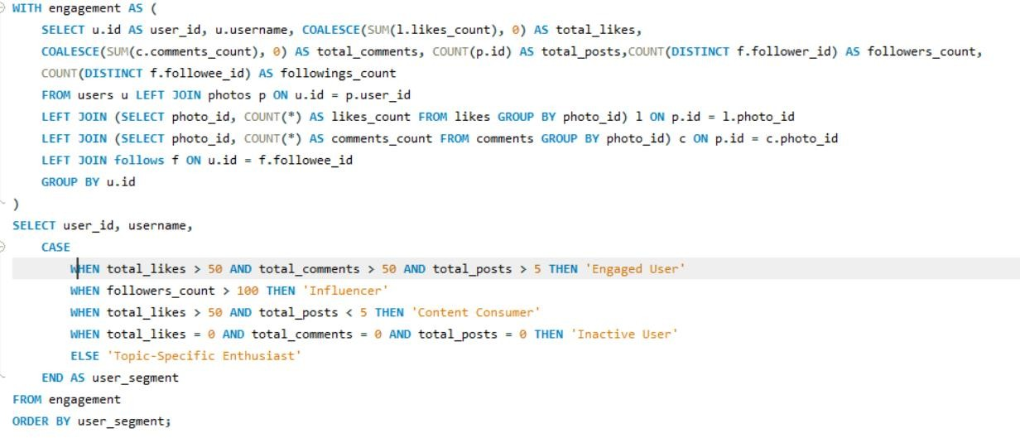

**Query result:**

|  |  |  |
| --- | --- | --- |
| **user_id** | **Username** | **user_segment** |
| 1 | Kenton_Kirlin | Engaged User |
| 2 | Andre_Purdy85 | Engaged User |
| 3 | Harley_Lind18 | Engaged User |
| 4 | Arely_Bogan63 | Engaged User |
| 86 | Delfina_VonRueden68 | Engaged User |
| 6 | Travon.Waters | Engaged User |
| 87 | Rick29 | Engaged User |
| 8 | Tabitha_Schamberger11 | Engaged User |

**Explanation**:

**Engagement CTE:**

* It calculated the total number of likes, comments, posts, and followers for each user. It aggregates the data from the likes, comments, photos, and follows tables.

**Segmentation:**

* Users are segmented based on their total engagement.

**7.If data on ad campaigns (impressions, clicks, conversions) is available, how would you measure their effectiveness and optimize future campaigns?**

Ans:

To measure the effectiveness of ad campaigns and optimize future campaigns, one need to evaluate key metrics such as:

**Impression Count:** How many times an ad is shown.

**Click-Through Rate (CTR**): The ratio of clicks to impressions.

**Conversion Rate:** The percentage of users who clicked the ad and performed a desired action (conversion).

**Cost Per Click (CPC):** The average cost paid per click.

**Return on Investment (ROI):** The revenue generated compared to the ad spend.

With data on impressions, clicks, conversions, and costs, we can perform the following analysis:

Let's assume we have a table `ad campaigns` with the following structure:

**Query:**

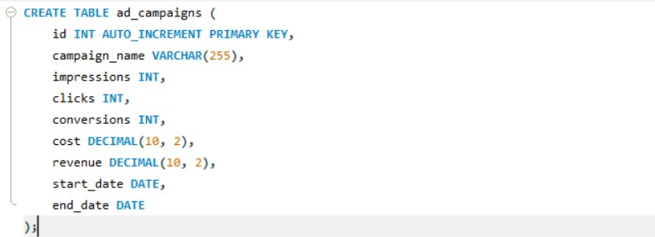

**Explanation:**

* **CTR (Click-Through Rate): Calculated as (clicks / impressions) * 100**. It measures the effectiveness of ads in generating clicks. A higher CTR indicates that the ad is appealing to users.
* **Conversion Rate: Calculated as (conversions / clicks) * 100**. It shows how well clicks are turning into actual conversions (such as purchases or sign-ups).
* **CPC (Cost Per Click): Calculated as cost / clicks**. This tells you how much you are spending for each click. Lower CPC means more efficient spending.
* **ROI (Return on Investment): Calculated as ((revenue - cost) / cost) * 100**. This is the key metric to determine whether the campaign is profitable.

**Optimizing Future Campaigns:**

* **Improve CTR:** Experiment with different ad creatives, headlines, and targeting options to increase the click-through rate.
* **Boost Conversion Rate:** Focus on landing page optimization and better call-to- actions (CTAs) to ensure that more clicks convert into actions.
* **Lower CPC:** Try adjusting bidding strategies, targeting more relevant audiences, or using A/B testing for keywords and ad copy.
* **Maximize ROI:** Allocate more budget to high-ROI campaigns and reduce spend on underperforming ones.

**8.How can you use user activity data to identify potential brand ambassadors or advocates who could help promote Instagram's initiatives or events?**

Ans:

To identify potential brand ambassadors or advocates using user activity data on Instagram, we can examine various metrics that reflect their engagement and influence on the platform. The key attributes to consider include:

**Key Metrics for Brand Ambassadors:**

* **Follower Count:** Users with a large follower base, indicating they have reach and influence over others
* **Engagement Rate:** High activity levels in terms of likes, comments, and posts, demonstrating active participation.
* **Content Creation:** Users who post a large number of photos and actively use tags, indicating that they frequently share content.
* **Interaction:** Users who receive a high number of likes and comments on their posts, showing that others engage with their content.
* **Consistency:** Users who post consistently and engage over time, indicating long- term commitment and presence on the platform.

**Query:**

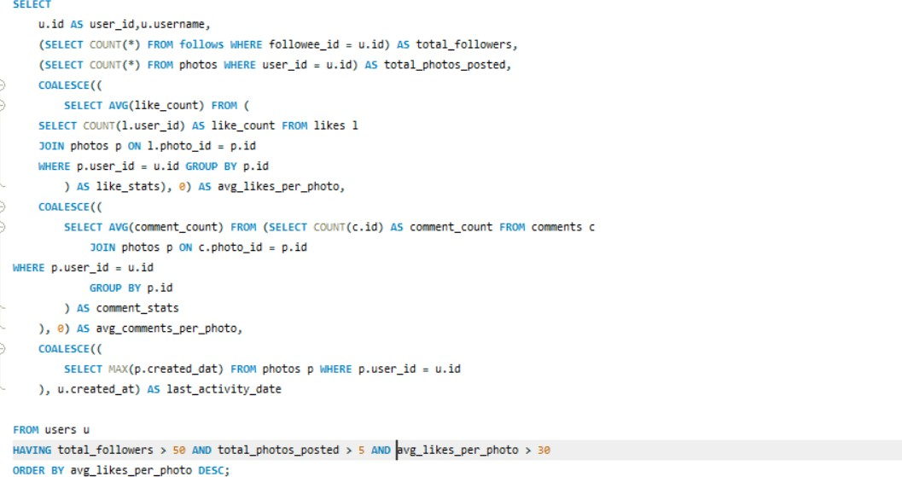

**Query Result:**

|  |  |  |  |  |  |  |
| --- | --- | --- | --- | --- | --- | --- |
| **user_id** | **username** | **total_followers** | **total_photos_posted** | **avg_likes_per_photo** | **avg_comments_per_photo** | **last_activity_date** |
| 77 | Donald.Fritsch | 77 | 6 | 36.3333 | 29 | 09-10-2024 17:05 |
| 23 | Eveline95 | 77 | 12 | 35 | 27.4167 | 09-10-2024 17:05 |
| 58 | Aurelie71 | 77 | 8 | 35 | 30.25 | 09-10-2024 17:05 |
| 29 | Jaime53 | 77 | 8 | 33.875 | 28.625 | 09-10-2024 17:05 |
| 59 | Cesar93 | 77 | 10 | 33.8 | 30.8 | 09-10-2024 17:05 |
| 88 | Clint27 | 77 | 11 | 32.8182 | 27.1818 | 09-10-2024 17:05 |
| 86 | Delfina_VonRueden68 | 77 | 9 | 31.6667 | 30.3333 | 09-10-2024 17:05 |

**Explanation:**

* Follower Count: The subquery SELECT COUNT(*) FROM follows WHERE followee_id = u.id determined how many users follow a particular user, which helps measure their influence.
* Content Creation: The number of photos a user has posted is determined by counting rows in the photos table where user_id = u.id.
* Average Likes and Comments: These subqueries calculate the average likes and comments per photo, giving an idea of how engaging the user's content is.
* Activity Level: The most recent post's date (MAX(p.created_dat)) indicates the user's recent activity.

This query will create a ranked list of potential brand ambassadors by looking at their engagement metrics, such as follower count, number of posts, average likes and comments per photo, and recent activity. These users can be targeted to promote Instagram's initiatives or events because of their strong engagement and influence on the platform.

**9.How would you approach this problem, if the objective and subjective questions weren't given?**

**Ans:**

I would approach the problem methodically and systemically. Here's a step-by-step outline of how I would tackle this:

**Identifying Key Metrics:** Determining the essential metrics for assessing user engagement, retention, and acquisition. These may include:

* Total number of photos posted
* Average likes and comments per user
* Growth rate of followers over time
* Engagement rates (likes and comments per photo)

**Define Key Questions and Metrics:**

**Engagement Metrics:**

* Average likes and comments per user and per photo.
* User activity levels, including the frequency of posting, commenting, and liking.

**Acquisition Metrics:**

* Monthly growth of new users.
* Conversion rate from visitors to registered users.

**Data Analysis:**

**Engagement Analysis:**

* Analyze likes and comments to identify trends, such as which types of photos receive the most engagement and which days or times experience higher activity levels.

**Retention Analysis:**

* Monitor the number of returning users and assess their activity levels over time.

**Acquisition Analysis:**

* Review new user registrations and track growth trends. Evaluate whether new users engage similarly to long-term users

**Targeted Content Strategy:**

* Identify high-performing content (based on likes/comments) and recommend strategies for encouraging similar content creation among users.

**User Engagement Initiatives:**

* Propose initiatives such as challenges, contests, or campaigns t0incentivize users to post more actively.

**Retention Programs:**

* Suggest loyalty programs or features that encourage users to log in daily or weekly, such as personalized content feeds based on their interaction history.

**Acquisition Channels:**

* Recommend marketing strategies focusing on platforms where potential users are most active, utilizing data from current user demographics and behaviour.

**10.Assuming there's a "User Interactions" table tracking user engagements, how can you update the "Engagement Type" column to change all instances of "Like" to "Heart" to align with Instagram's terminology?**

Ans:

To update the "Engagement_Type" column in the "User_Interactions" table and change all instances of "Like" to "Heart," you can use the SQL UPDATE statement. Here's how you can do it:

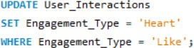**Query**:

**Explanation**:

* **UPDATE User_Interactions:** This specifies the table you want to update, which in this case is "User_Interactions."
* **SET Engagement_Type =** 'Heart': This indicates that you want to change the value of the "Engagement_Type" column to "Heart."
* **WHERE Engagement_Type =** 'Like': This condition ensures that only the rows where "Engagement_Type" is currently set to "Like" will be affected by the update.